 | 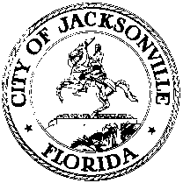
 | OFFICE OF THE CITY COUNCIL
ANNA LOPEZ BROSCHE  PRESIDENT  JACKSONVILLE CITY COUNCIL  OFFICE (904) 630-1452 |  | SUITE 425, CITY HALL  117 WEST DUVAL STREET  JACKSONVILLE, FLORIDA  32202
TASK FORCE ON OPEN GOVERNMENT
AGENDA
June 12, 2018
Don Davis Room
1:00 pm

Introductions

Public Records- State Attorney’s Office
State Attorney Melissa Nelson

Ethics Office-City gift policy
Ethics Director Carla Miller

Discussion

Public Comment

Chairs: Hank Coxe and Dr. Sherry Magill
Members: Ywana Allen
Rachael Fortune
The Honorable Alberta Hipps
Ron Littlepage
Michael Lockamy
Audrey Moran
The Honorable Jim Overton
Sabeen Perwaiz
Cleve Warren

The next Task Force Meeting will be Tuesday, June 19, 2018 1:00 pm in the Don Davis Room
117 West Duval Street, First Floor

